JOUR 4251
Advertising and behavior change (Principles of compliance) - Ch 7 part 2
Principles of compliance
● Reciprocity
● Commitment/consistency ● Social validation (consensus) ● Friendship/Liking
● Scarcity
● Authority
● Confusion
Reciprocity principle
Door-in-the-face technique
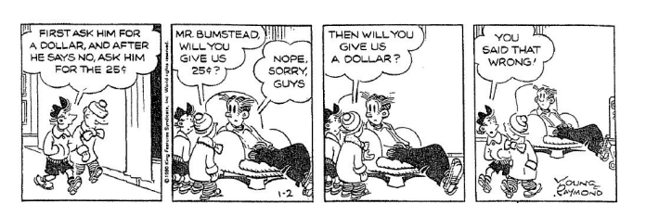Needs to be ONE person asking. Doesn’t work if different people ask.
Reciprocity principle
That’s not all technique
Reduced price
Added value to fixed price (make-up bonus)
Infomercials: Wait, that’s not all. If you call now, we will add.. REMEMBER: works when mindless. Not thinking.
Commitment/consistency
● Foot-in-the-door technique
○ Small request followed with big target request
● Bait-and-switch technique
○ Induce commitment and then remove the inducements that generated commitment
● Low-ball technique
○ Change terms after commitment
● Four walls technique
○ Yes, yes, yes => make commitment
Social validation (consensus)

Social validation
Social proof
We turn to others for assessing the merits of a message or offer. Others like me or whose opinion I value think it’s a good choice Reference groups:
A person/group act as agents of social proof. They communicate standards.
Confusion Principle
Slightly confuse consumer can help make sales Disrupt then reframe technique
200 pennies, instead of $2
It disrupts our ability to counterargue
Think like an advertiser!
1. Pick a product
2. Choose one of the principles of compliance 3. Make an ad for this product using the principle
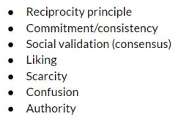
What’s next?
● Submit reading response #9 on new readings
○ Check out two book chapters by Schiffman et al. (Library Course page)
○ Deadline April 9
● Assignment #4 on behavior is due by April 23

